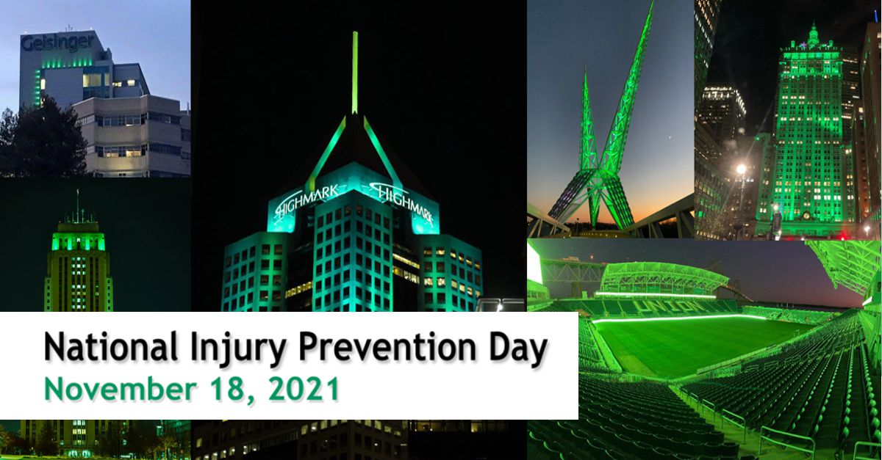

Twitter Chat 101 for Participants

- Thanks so much for participating in the second annual Twitter chat for National Injury Prevention Day on Wednesday, November 18th.

- Our Twitter chat is set for November 18th at 1-2pm EST.

- Before the date:
  - Follow @InjuryFreeKids and others in injury prevention
  - Reach out to social media partners about promoting the Twitter chat
  - Promote the chat on your own accounts. Start posting about NIPD as soon as possible! Feel free to use the promotional posts or our photos from 2020 with buildings lit up green that can be found on the Resource page.
  - Use the hashtag: #BeInjuryFree in every response
  - Review Twitter chat questions (below) and craft your responses beforehand. This is NOT mandatory, but it help minimize stress during the Twitter chat!
    - Great responses might include:
      - Links to important references - make sure the link works and the website looks good. You can shorten links by going to tinyurl.com.
      - Relevant images, GIFs, and videos
      - Appropriate hashtags and mentions (using handles starting with @)
  - These steps are not mandatory, but highly recommend to maximize your impact.
- Day of Twitter chat:
  - Log onto Twitter a few minutes before the session starts.
  - You can either search @InjuryFreeKids and follow the chat or search #BeInjuryFree and sort by “Latest” to read the conversation as close to chronological order as possible.

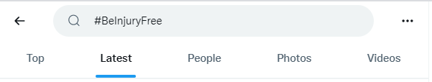

- You can also use Tweetdeck.twitter.com to follow the hashtag, Injury Free handle and your notifications…all at once! Add columns w/ the “+” sign.
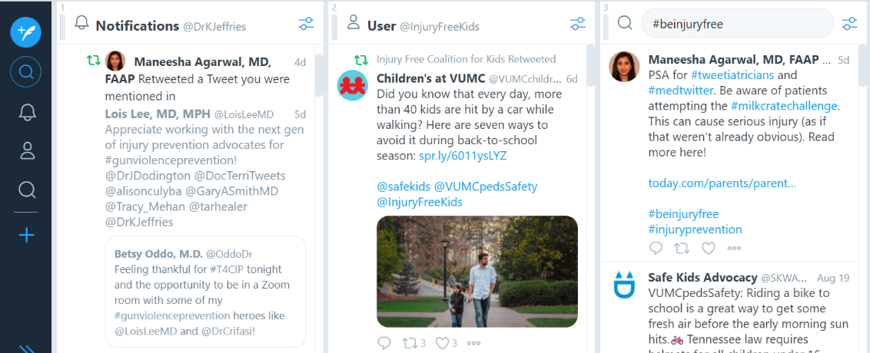

- As you read tweets, you can:
  - Like
  - Retweet
- Use #BeInjuryFree in every response.
  - You can respond to the questions using Quote Tweet, Reply, or posting as a new tweet.
  - Remember to include the Answer number (A1, A2, A3…) to help us know which question you are answering.
- Notifications: You will get notifications if someone likes, retweets or replies to your tweets, or mentions you. It can be hard to keep up in real time, but if there is some downtime in the conversation, we suggest you review your notifications as some people might be asking you questions.
- Engage with others! Answer questions and respond to other partners’ responses that you find interesting or especially useful!
- Have fun!! You can always go back to read all the tweets after the session is over by searching #BeInjuryFree.

Questions / Timeline

Welcome  1:00 pm EST | Welcome to National Injury Prevention Day Twitter chat! We are talking about several topics today regarding the number one cause of death in ages 1-44 years – injuries.
Instructions  1:01 pm EST | To participate in the chat, follow & use #BeInjuryFree in all responses. We encourage you to ask questions and engage with each other!  Partners: please use (A1, A2, A3…) with each answer response  corresponding to the question number (Q1, Q2, Q3…).
Introduction  1:02 pm EST | We are happy to have you join us in today’s chat. Who’s here? #BeInjuryFree  Partners: please jump in and introduce yourself.
Q1  1:05 pm EST | Q1. When it comes to cars and crashes, how do you promote passenger safety with kids and adults? #BeInjuryFree
Q2  1:10 pm EST | Q2. Firearm injuries are a leading cause of death in US children & young adults. How can we approach firearm safety with families? #BeInjuryFree
Q3  1:15 pm EST | Q3. Swimming, boating, beaches, lakes, pools, bathtubs! How do you talk to individuals about staying safe around water? #BeInjuryFree
Q4  1:20 pm EST | Q4. What are the strategies you use when you encounter your friends or family using unsafe sleep practices? #BeInjuryFree
Q5  1:25 pm EST | Q5. Unintentional poisonings are a leading cause of injury and death in almost all ages. What are some ways to address this in your community? #BeInjuryFree
Q6  1:30 pm EST | Q6. How has the pandemic affected mental health in your community, and how have you addressed this issue? #BeInjuryFree
Q7  1:35 pm EST | Q7. What steps can communities take to keep pedestrians safe around roadways? #BeInjuryFree
Q8  1:40 pm EST | Q8. What is an important piece of safety advice for riders of ATVs and other off-road vehicles? #BeInjuryFree
Q9  1:45 pm EST | Q9. Helmets are useful in preventing head injuries at all ages. How do you promote helmet use in bicycling and beyond? #BeInjuryFree
Q10  1:50 pm EST | Q10. Tell us your favorite injury prevention success story! #BeInjuryFree
Thanks  1:55 pm EST | That’s all the time we have today. HUGE thank you to our experts for sharing advice about preventing injuries at home, at work, and at play! #BeInjuryFree
Closing  1:56 pm EST | Our partners are available to keep the conversation going, so if you have any questions or feedback, feel free to reply to the chat tweets. Tag #BeInjuryFree to add your voice to the discussion.
Ending  1:57 pm EST | Follow our experts for more on #BeInjuryFree and thank you for joining us!

If you encounter trolls or off-topic responses:
● Let’s stay on the topic of preventing injuries to families, please. #BeInjuryFree

Have more questions? Please reach out to Lenita, and she will get you connected to resources from our social media committee, whether it’s a one-on-one zoom or phone call.

Example responses

These are some example responses from other Twitter chats. You can (1) link to resources on your website, (2) post graphics, with or without text, that grab attention and highlight your answer, or (3) add short video clips, PSAs, etc. with your answer.

